DAILY ONLINE ACTIVITIES SUMMARY

|  |  |  |  |  |  |  |  |
| --- | --- | --- | --- | --- | --- | --- | --- |
| **Date:** | **11-07-2020** | | | | **Name:** | **Kavya.R.Shetty** | |
| **Sem & Sec** | **6th sem, ‘A’ sec** | | | | **USN:** | **4AL17CS042** | |
| Online Test Summary | | | | | | | |
| **Subject** | | **Operating System** | | | | | |
| **Max. Marks** | | **-** | | **Score** | | **-** | |
| Certification Course Summary | | | | | | | |
| **Course** | **Blockchain Basics** | | | | | | |
| **Certificate Provider** | | | **Coursera** | **Duration** | | | **19hrs** |
| Coding Challenges | | | | | | | |
| **Problem Statement: 1 C program** | | | | | | | |
| **Status: executed** | | | | | | | |
| **Uploaded the report in GitHub** | | | | **Yes** | | | |
| **If yes Repository name** | | | | <https://github.com/kavya-shetty765/DAILY-> [STATUS](https://github.com/nandithashetty/DAILY-STATUS) | | | |
| **Uploaded the report in slack** | | | | **Yes** | | | |

**Coding Challenges Details:**

**Program 1**

This is output of C program to check whether a given character is a vowel or a consonant.

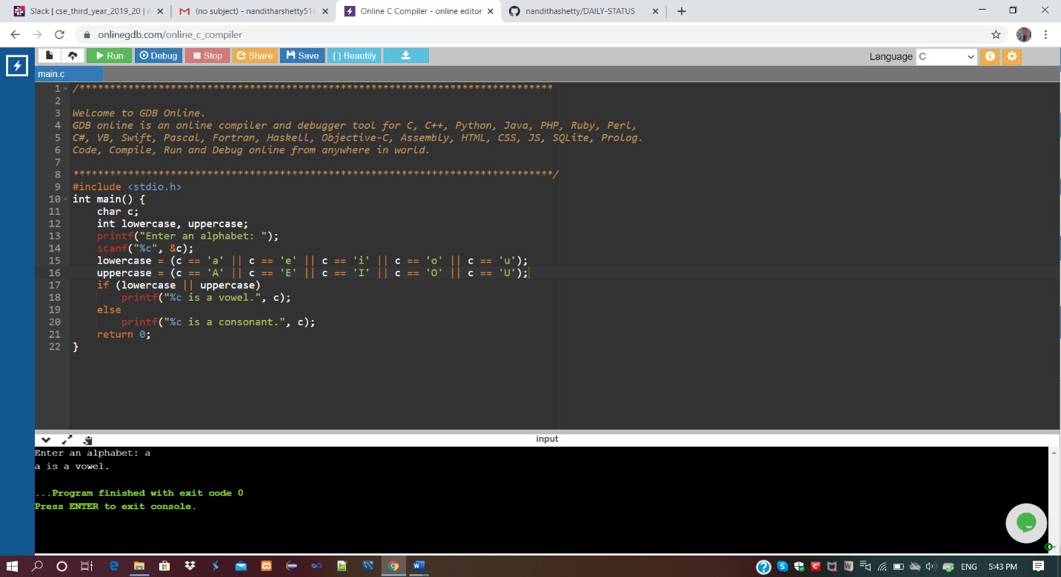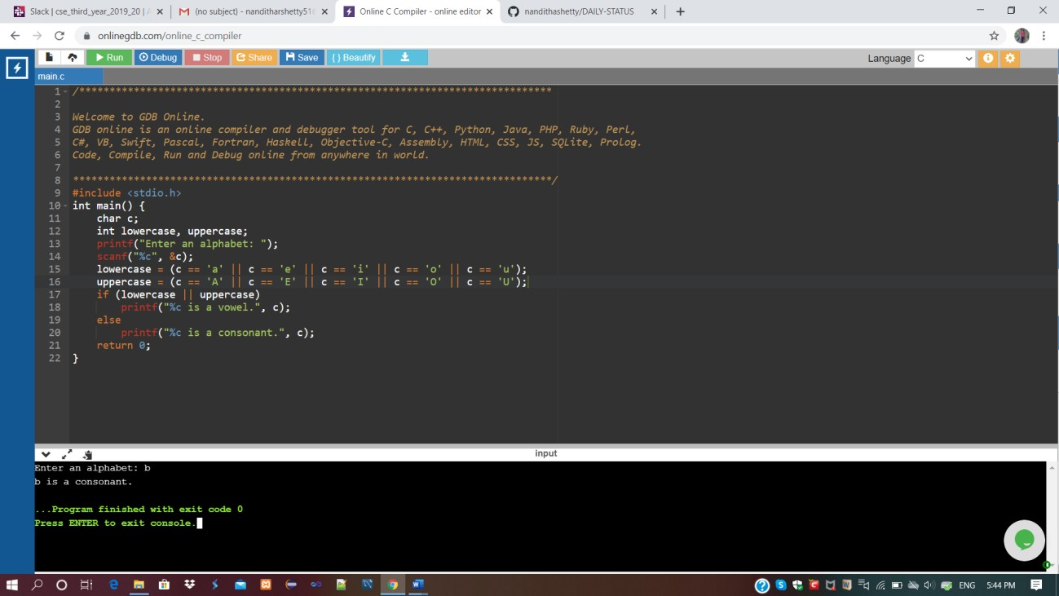

Refer GitHub for detailed Information:

<https://github.com/kavya-shetty765/DAILY-STATUS/tree/master/11-07-> [2020/ONLINE%20CODING](https://github.com/nandithashetty/DAILY-STATUS/tree/master/11-07-2020/ONLINE%20CODING)

This Report is also available in:

<https://github.com/kavya-shetty765/DAILY-STATUS/blob/master/11.07.2020/DAILY%20REPORT%201.docx>